EEE 117 Laboratory

Instructor: Sergio Aguilar-Rudametkin

Lab 3: OSCILLOSCOPE

Lab Report by: Angelica Smith-Evans

Lab Session: Friday, 4PM-6:30PM

Due Date of Report: 10/20/2017

Date(s) of Lab: 10/13/2017

Lab Partners: Kaicha Johnson, Rachana Tandel

1. **Introduction:**

An oscilloscope is a tool which is required for circuit analysis. It is used to measure constantly changing electrical signals. The oscilloscope can measure a electrical signals over the course of time. The oscilloscope is important tool which is used in various fields such as electrical engineering, medical fields, and also the car industry. Using and knowing the ins-and-outs of the oscilloscope is essential to understanding and analyzing electrical signals to the fullest.

1. **Purpose:**

The purpose of this lab is to become familiar with one of most important tools of circuit analysis, the oscilloscope as well as the waveform generator. Through the lab we will be using a waveform generator as an input into the circuit. The resulting oscillations will be analyzed using the oscilloscope. Using the oscilloscope, we analyze peak to peak measurement, as well as amplitude, transformations, and also compare and contrast two separate waveforms. In addition to introducing these two equipments, we will also be getting more familiar using the digital multimeter. As an electrical engineer, it is very important for us to get comfortable using the oscilloscope.

1. **Discussion and Results:**

Part 1:

The first part of this lab is to show how to read voltage of a waveform from the screen of the oscilloscope. The calibrator voltage is used to see a constant waveform. Using the channel 2 voltage, we discovered that the voltage running through the oscilloscope is at about 2.12V starting at t=0s, voltage peak-to-peak. This is found by using the X10 probe.   
Using the waveform generator by connecting to channel 1 of the oscilloscope, and measuring with the X10 probe. By setting the function generator to 1KHz , and 1 volt peak-to-peak with 0 volt offset, we see a waveform. However, by changing the offset to 1 volt DC, the waveform transformed upwards by a factor of 2volts. Therefore, a DC offset in the positive direction will make a transformation of the waveform upwards. Looking at the oscilloscope, this shows that the DC offset increases the magnitude of the voltage.

However, using an AC offset, no matter the magnitude, it does not transform the waveform. Looking at the changes between AC offset of 0V and also AC offset of 1V, there is no visible transformations of the waveform like that of a DC offset. This means that the AC offset does not affect the magnitude.

Connecting a circuit as shown in Fig. 1, there is three major components, two resistors and one capacitor connecting in parallel and series formations. The resistance which would give an offset of 45 degree, R is, ideally, 1616.48 Ohm. The closest measured resistance is an Ro = 1581 Ohm. The chosen resistor to represent the 100 kOhm R1 = 108 kOhm. The measured capacitance to represent the 0.1 microFerrid is 0.09577  
 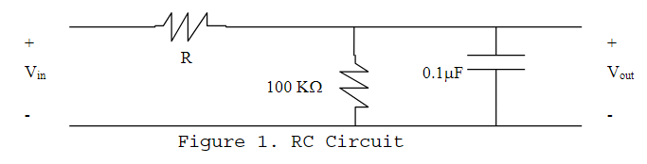

Connecting Vin to the function generator with 1 volt peak-to-peak, 1 KHz, and 0 DC offset, and connecting Vout to the digital multimeter, as well as connecting Vin and Vout to the oscilloscope to measure the waveforms, we will see how closely the theoretical values compare to the actual values we have used to compose this circuit. This picture below is the visual representation of what is happening on the oscilloscope screen.

Fig 2)

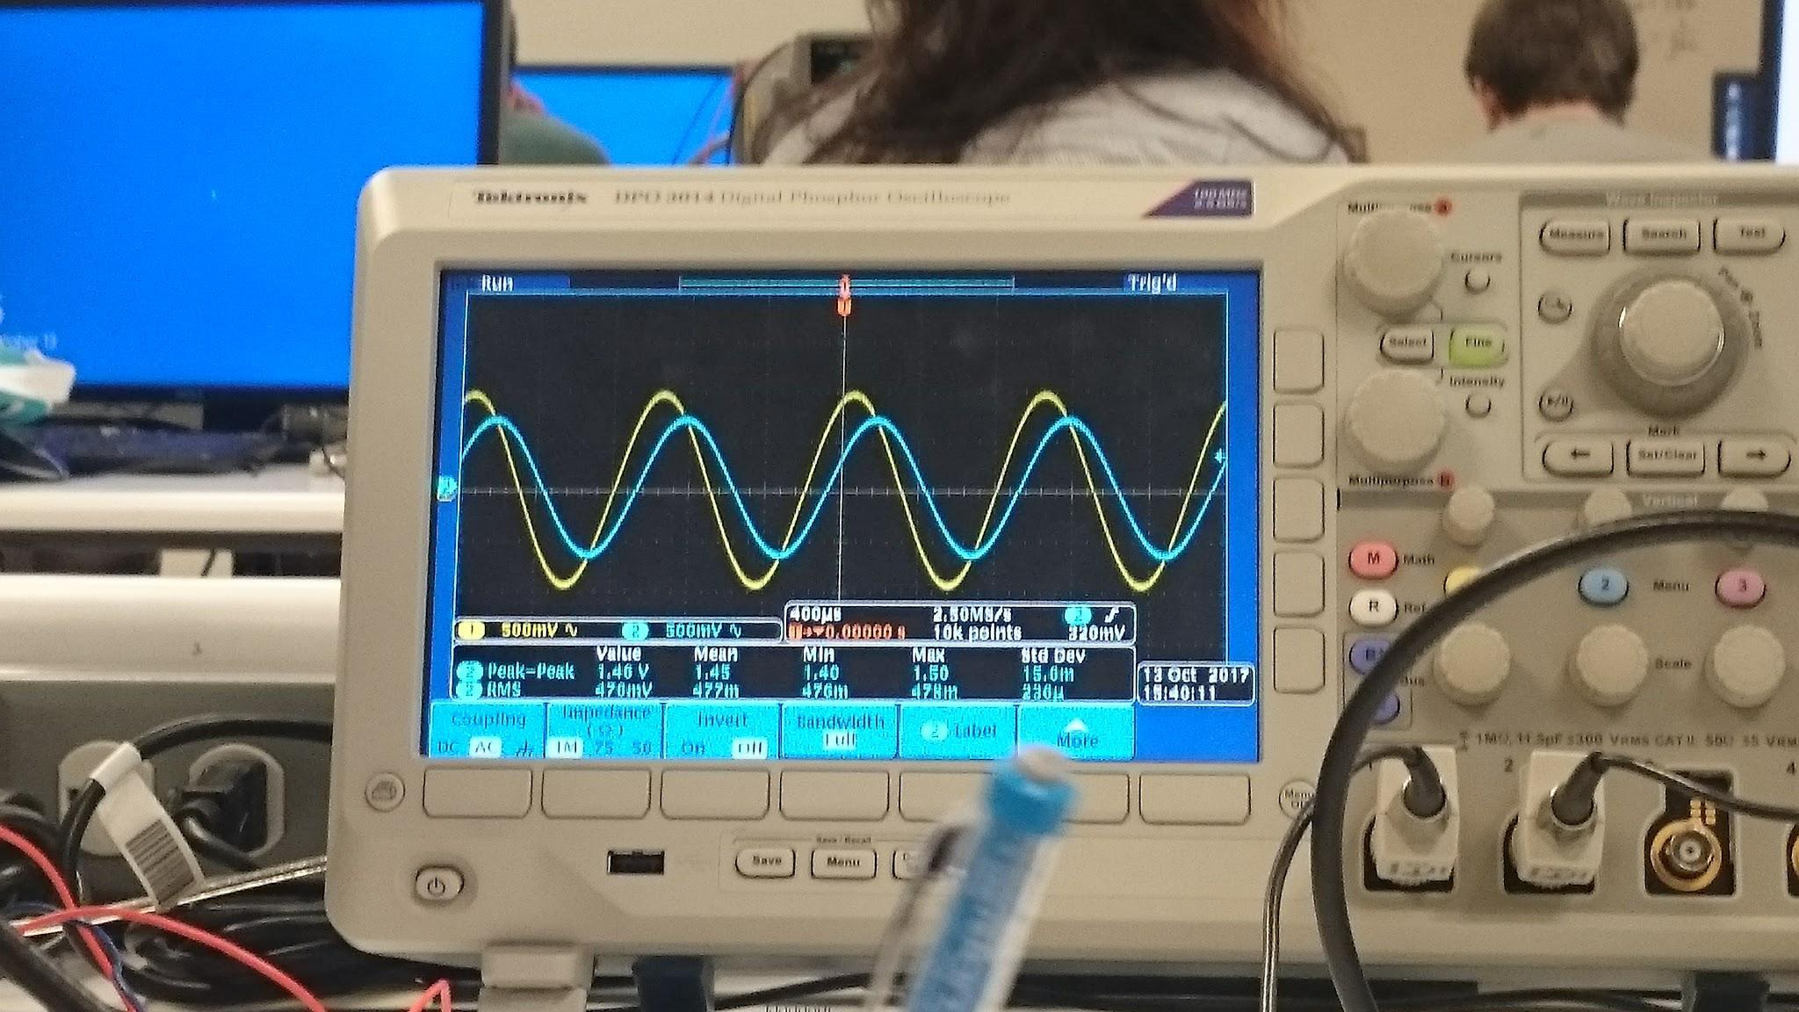

Part 2:

Playing around with oscilloscope controls show what happens to a waveform as the oscilloscope’s several buttons are pressed. Using the oscilloscope’s slope/coupling control and switching from positive to negative coupling, there is a right-hand shift. This shows that the coupling can move the waveform to the right. Also, switching from “auto” to “normal” we did not notice any difference in the measurement of the waveforms. However, by zooming out of the scope of the waveform, if it is on “normal” mode, then the waveform will be stable. However, the “auto” mode will let the waveforms move freely.

Fig. 3 below shows the values of the waveform analyzed. Looking at the voltage values read on the screen, the values listed in the table below show the Vin and Vout values measured by the oscilloscope. As seen below, the changes between V*in* and Vout is about 0.6 volt.

Fig 3)

|  |  |  |  |  |  |
| --- | --- | --- | --- | --- | --- |
| Vout p-p = 1.44V | value(v) | mean(v) | min(v) | max(v) | Std. dev.(mV) |
| 1 = Vin | 1.88 | 1.88 | 1.86 | 1.88 | 6mV |
| 2 = Vout | 1.2 | 1.25 | 1.2 | 1.56 | 95mV |

Part 3:

We connect a 1 Vp-p with 1 KHz with 0 volt offset. By choosing an approximately 51 Ohm resistor across a function generator versus measuring without the 51 Ohm resistor, there is a small offset. When the function generator is connected to the 51.02 Ohm resistor, it is in fact the correct reading.

The most important aspect of this analysis is the final portion which shows the actual phase shift. Looking at the waveform, the phase shift can be calculated by Phi = (360 * (200*(⅗ ms))/(1/1000ms)). This describes the actual phase shift of the waveforms as described by the oscilloscope. The calculation came out to be 43.2 degree. This is very close to the ideal of 45 degree phase shift in which we set our goals to.

The frequency and time can be given to us by the oscilloscope measurements in the Measure section, or it can be observed based on analysis of the oscilloscope waveforms, as shown in fig. 4.

Fig. 4)

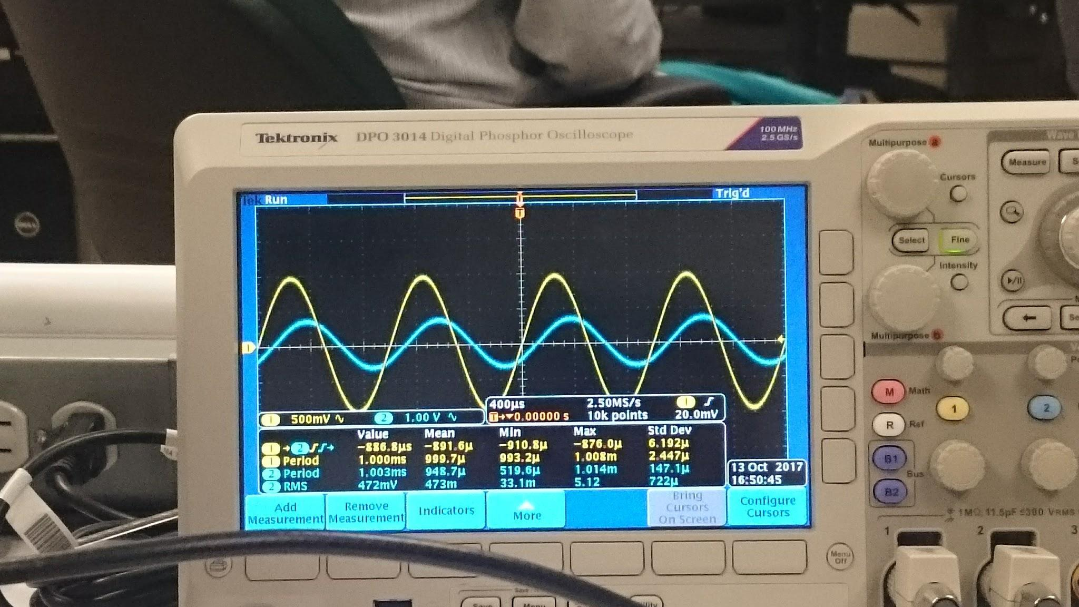

1. **Conclusion:**

The oscilloscope is a tool which is both powerful and versatile. It can do many things and it can show so much about a waveform. It is a powerful tool in circuit analysis. Using the oscilloscope is both difficult and also rewarding. Throughout the lab assignment, there was some difficulties learning how to use and traverse the oscilloscope interface. It proved difficult in some areas as there were times when we found it difficult or hard to proceed. At times, we had to refer to the documentation, but even then it was difficult to see or know how to proceed based on the lab directions.

As for the readings of the circuit, there is a level of inaccuracy from the theoretical analysis versus the actual analysis. However, although we need specific components for an accurate analysis, it is hard to get a component with the most accuracy. For example, the resistor we needed for Ro needed to be 1616 Ohm, while the closest we could get at the time was 1581 Ohm. This kind of derails our analysis since we cannot get a component that matches our needs at the time.

However, I would consider this analysis a success as the phase shift calculated was 43.2 degrees, which is very close to the theoretical prediction of 45 degrees. I believe that the analysis could have been more accurate if there were more accuracy to the ideal.